ChE 205 – Computational Methods in Chemical Engineering – Fall 2018
Student Learning Outcome 1
Rubric for assessment problem on final exam (Problem # 1c, 3, 6, and 2a)
Application of computational methods in solving chemical engineering problems.

SLO 1  Performance Indicator (PI) | (1) Unsatisfactory | (2) Developing | (3) Satisfactory
1. Apply mathematical and scientific principles to formulate models and systems relevant to the subject  Problem 1c, 8 pts | Able to successfully combines mathematical and/or scientific principles to formulate models and systems relevant to chemical engineering  (<4 pts) | Chooses a mathematical model or scientific principle that applies to an engineering problem, but has trouble in model development  (4-6 pts) | Does not understand the connection between mathematical models and the system or process to be analyzed or designed  (>6 pts)
2. Solve engineering problems by using the concepts of algebra, calculus, differential equations and/or linear algebra  Problem 3, 10 pts | applies concepts of algebra, calculus, differential equations and/or linear algebra to solve chemical engineering problems  (<4 pts) | Shows nearly complete understanding of applications of calculus and/or linear algebra in problem-solving  (4-7 pts) | Does not understand the application of algebra, calculus, differential equations and/or linear algebra in solving chemical engineering problems  (>7 pts)
4. Translates academic theory into engineering applications  Problem 6, 5 pts | Translates academic theory into engineering applications and accepts limitations of mathematical models of physical reality  (< 2 pts) | Some gaps in understanding the application of theory to the problem and expects theory to predict reality  (2-3 pts) | Does not appear to grasp the connection between theory and the problem  (>3 pts)
6. The uses of appropriate resources needed to solve problems  Problem 2a, 4 pts | Uses no resources to solve problems  (< 2 pts) | Uses limited resources to solve problems  (2-3 pts) | Uses appropriate resources to locate information needed to solve problems  (>3 pts)

Averages:

Performance Indicators: (1) 2.48 (2) 1.66 (4) 2.52 (6) 2.55
Overall Average: 2.30
Standard Deviation: 0.37

Average scores were fairly uniform across Performance Indicators (PI) 1, 4, and 6. A rather low score was observed in PI 2, designated for problem 3. Also, there was wide variation of PI among students. This data suggests that most students were strong in (i) applying mathematical and scientific principles to formulate models, (ii) translate academic theory into engineering applications, and (iii) uses of appropriate resources needed to solve problems; however they were weak in solving engineering problems using differential equations and linear algebra (16/29 were unsatisfactory to solve problem 2).

CHE 205 Final Exam 12/12/2018

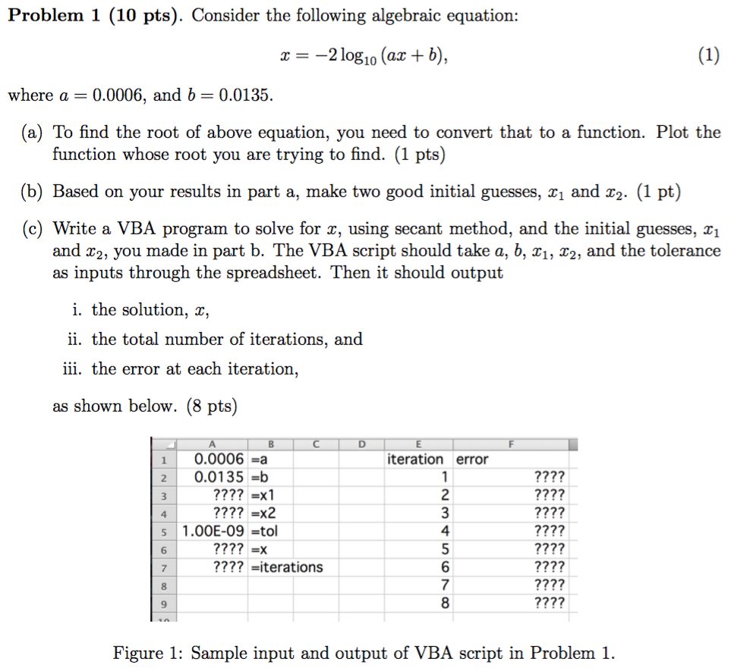

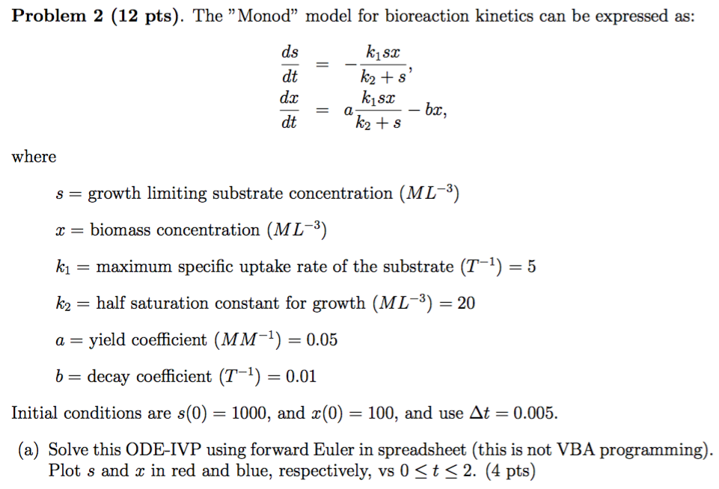

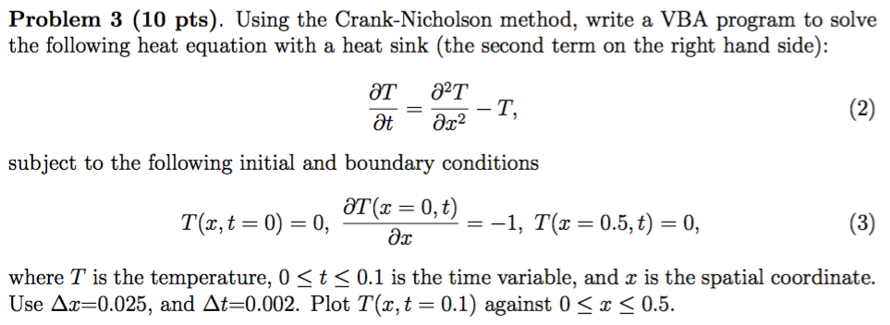

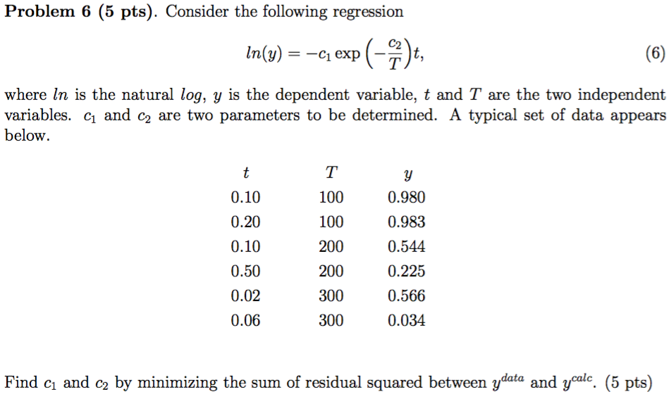

Solutions

Problem 1c:
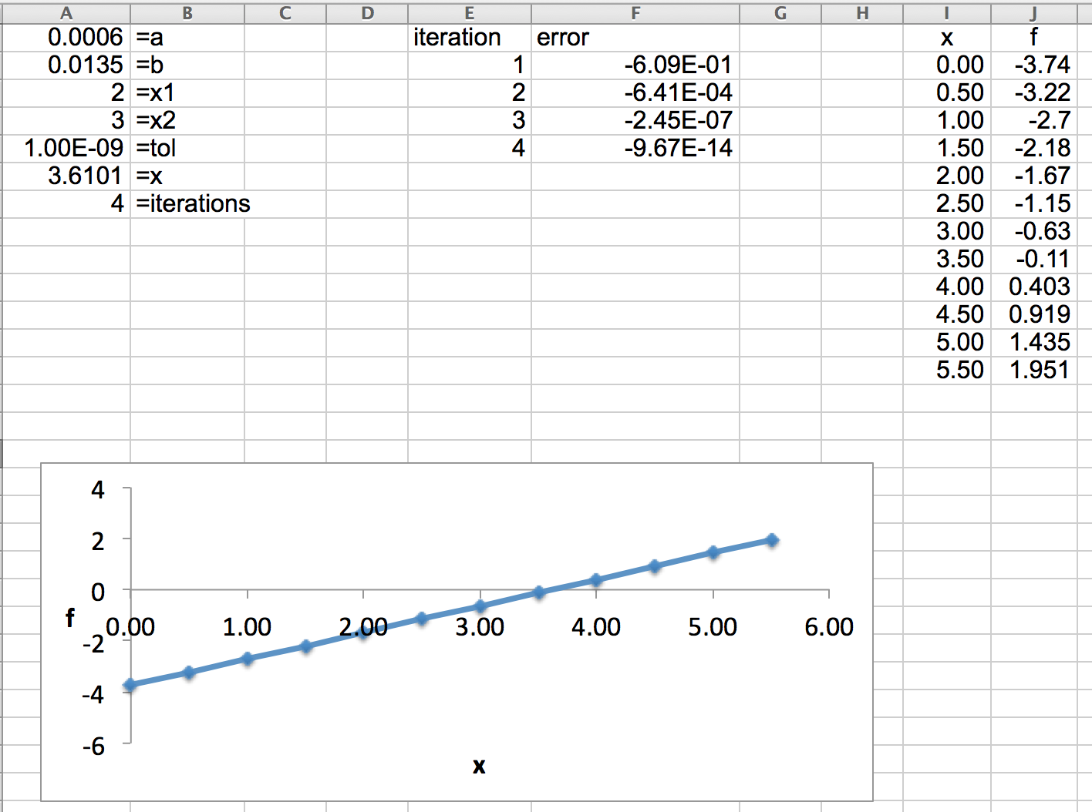
---------------------------------------------------------------------------------------------------------------------------------
Problem 2a:
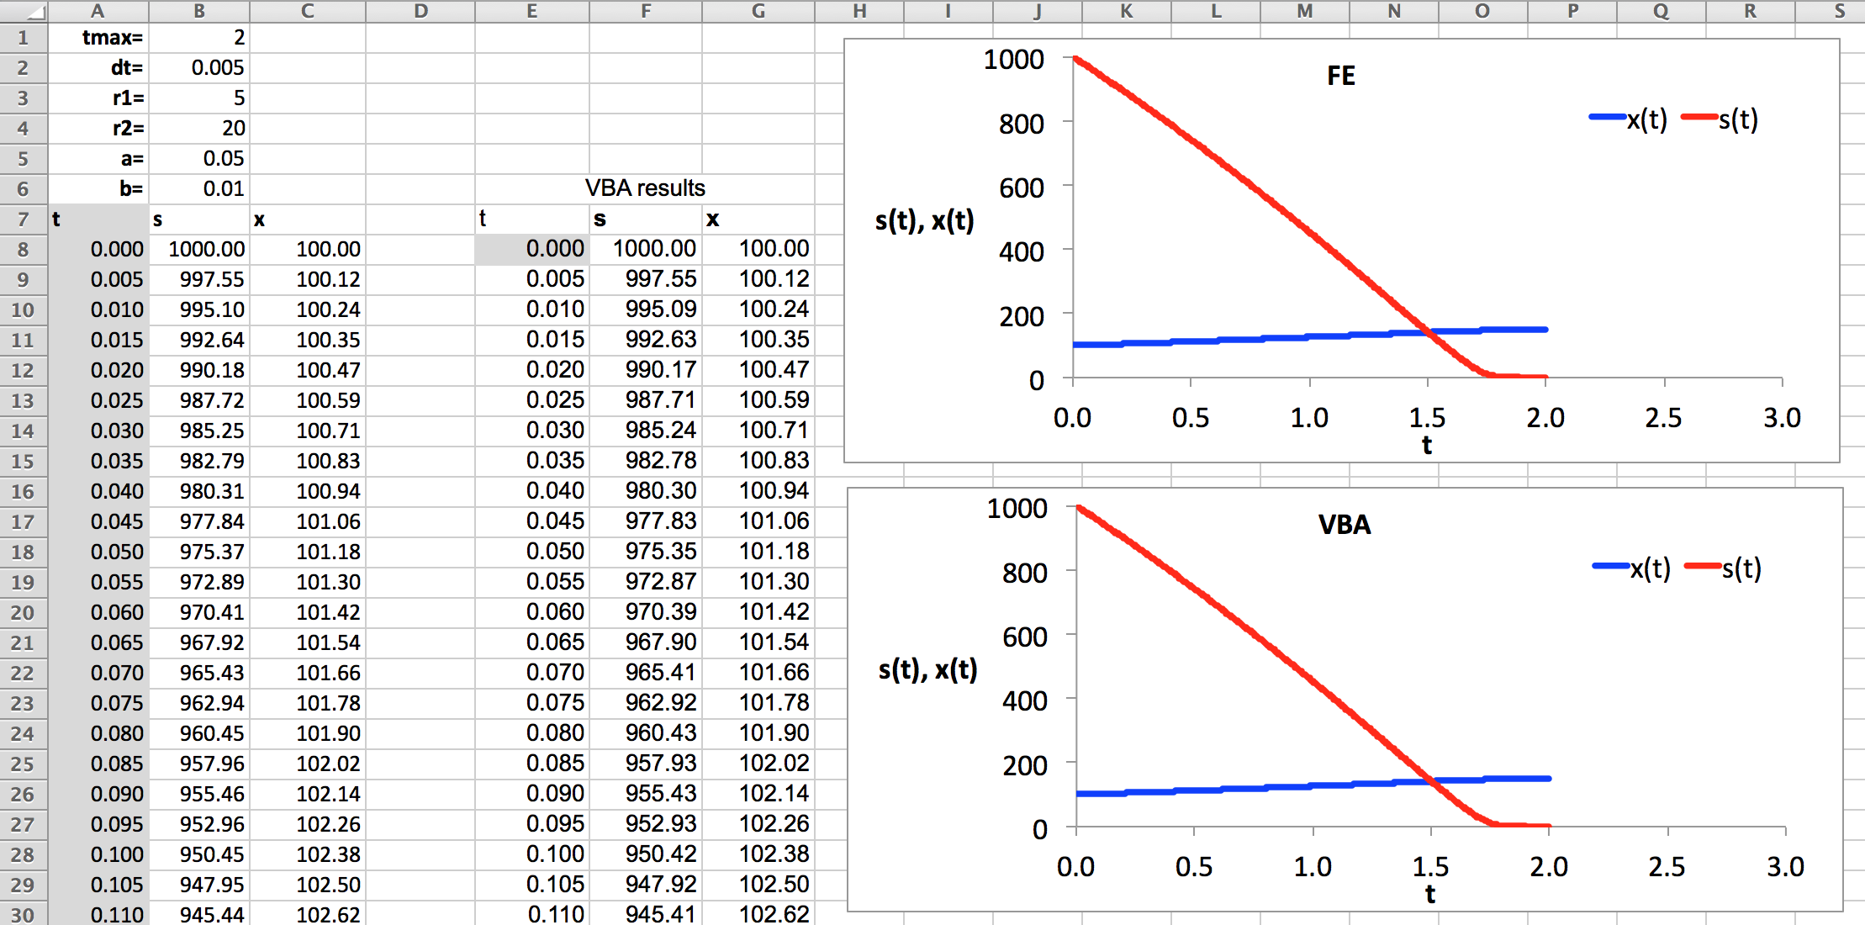

---------------------------------------------------------------------------------------------------------------------------------
Problem 3
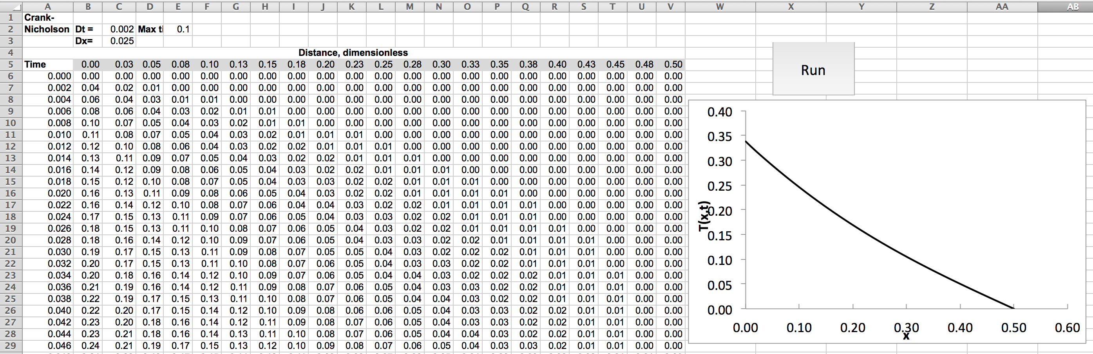

---------------------------------------------------------------------------------------------------------------------------------
Problem 6
